**Practical No. 9**

**Aim:** Introduction to Wireshark.

1. **What is Wireshark?**

Wireshark is an open-source packet analyzer, which is used for ****education, analysis, software development, communication protocol development, and network troubleshooting****.

It is used to track the packets so that each one is filtered to meet our specific needs. It is commonly called as a ****sniffer, network protocol analyzer, and network analyzer****. It is also used by network security engineers to examine security problems.

Wireshark is a free to use application which is used to apprehend the data back and forth. It is often called as a free packet sniffer computer application. It puts the network card into an unselective mode, i.e., to accept all the packets which it receives.

1. **Uses of Wireshark**
2. Wireshark can be used in the following ways:
3. It is used by network security engineers to examine security problems.
4. It allows the users to watch all the traffic being passed over the network.
5. It is used by network engineers to troubleshoot network issues.
6. It also helps to troubleshoot latency issues and malicious activities on your network.
7. It can also analyze dropped packets.
8. It helps us to know how all the devices like laptop, mobile phones, desktop, switch, routers, etc., communicate in a local network or the rest of the world.
9. **What is a packet?**

A packet is a unit of data which is transmitted over a network between the origin and the destination. Network packets are small, i.e., maximum 1.5 Kilobytes for Ethernet packets and 64 Kilobytes for IP packets. The data packets in the Wireshark can be viewed online and can be analyzed offline.

1. **History of Wireshark:**

In the late 1990's Gerald Combs, a computer science graduate of the University of Missouri-Kansas City was working for the small ISP (Internet Service Provider). The protocol at that time did not complete the primary requirements. So, he started writing ethereal and released the first version around 1998. The Network integration services owned the Ethernet trademark.

Combos still held the copyright on most of the ethereal source code, and the rest of the source code was re-distributed under the GNU GPL. He did not own the Ethereal trademark, so he changed the name to Wireshark. He used the contents of the ethereal as the basis.

Wireshark has won several industry rewards over the years including eWeek, InfoWorld, PC Magazine and also as a top-rated packet sniffer. Combos continued the work and released the new version of the software. There are around 600 contributed authors for the Wireshark product website.

1. **Functionality of Wireshark:**

Wireshark is similar to tcpdump in networking. Tcpdump is a common packet analyzer which allows the user to display other packets and TCP/IP packets, being transmitted and received over a network attached to the computer. It has a graphic end and some sorting and filtering functions. Wireshark users can see all the traffic passing through the network.

Wireshark can also monitor the unicast traffic which is not sent to the network's MAC address interface. But, the switch does not pass all the traffic to the port. Hence, the promiscuous mode is not sufficient to see all the traffic. The various network taps or port mirroring is used to extend capture at any point.

Port mirroring is a method to monitor network traffic. When it is enabled, the switch sends the copies of all the network packets present at one port to another port.

1. **What is color coding in Wireshark?**

The packets in the Wireshark are highlighted with blue, black, and green color. These colors help users to identify the types of traffic. It is also called as packet colorization. The kinds of coloring rules in the Wireshark are temporary rules and permanent rules.

* The temporary rules are there until the program is in active mode or until we quit the program.
* The permanent color rules are available until the Wireshark is in use or the next time you run the Wireshark. The steps to apply color filters will be discussed later in this topic.

1. **Features of Wireshark**

* It is multi-platform software, i.e., it can run on Linux, Windows, OS X, FreeBSD, NetBSD, etc.
* It is a standard three-pane packet browser.
* It performs deep inspection of the hundreds of protocols.
* It often involves live analysis, i.e., from the different types of the network like the Ethernet, loopback, etc., we can read live data.
* It has sort and filter options which makes ease to the user to view the data.
* It is also useful in VoIP analysis.
* It can also capture raw USB traffic.
* Various settings, like timers and filters, can be used to filter the output.
* It can only capture packet on the PCAP (an application programming interface used to capture the network) supported networks.
* Wireshark supports a variety of well-documented capture file formats such as the PcapNg and Libpcap. These formats are used for storing the captured data.
* It is the no.1 piece of software for its purpose. It has countless applications ranging from the tracing down, unauthorized traffic, firewall settings, etc.

1. **Installation of Wireshark Software**

Below are the steps to install the Wireshark software on the computer:

* Open the web browser.
* Search for 'Download Wireshark.'
* Select the Windows installer according to your system configuration, either 32-bt or 64-bit.
* Save the program and close the browser.
* Now, open the software, and follow the install instruction by accepting the license.
* The Wireshark is ready for use.

On the network and Internet settings option, we can check the interface connected to our computer. By selecting the current interface, we can get the traffic traversing through that interface. The version used here is ****3.0.3****. This version will open as: 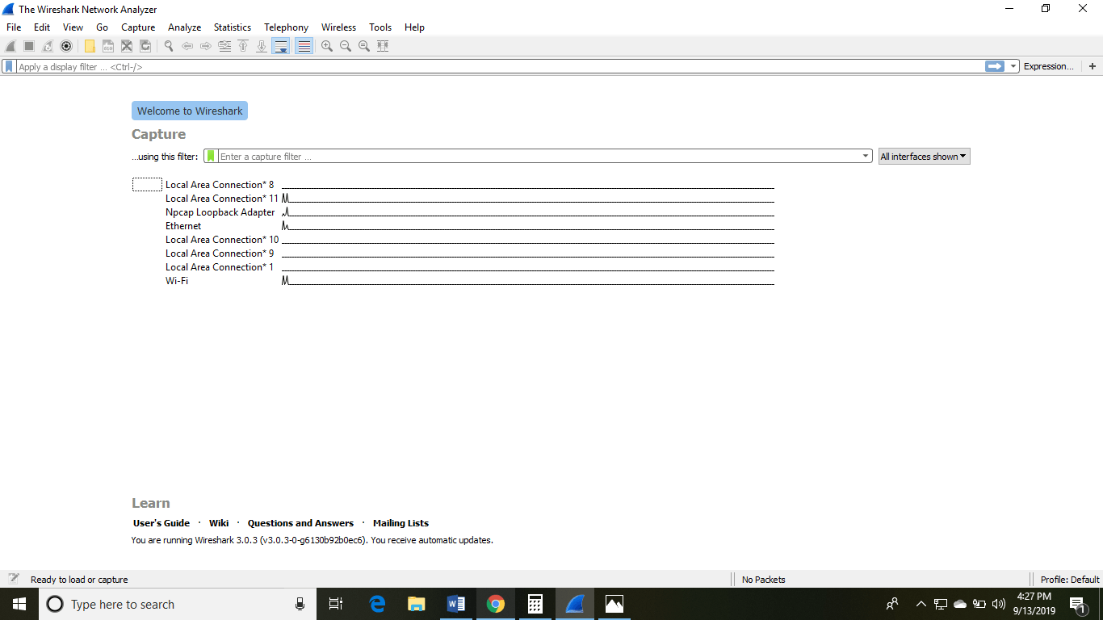

The Wireshark software window is shown above, and all the processes on the network are carried within this screen only.

The options given on the list are the Interface list options. The number of interface options will be present. Selection of any option will determine all the traffic. ****For example,**** from the above fig. select the Wi-Fi option. After this, a new window opens up, which will show all the current traffic on the network. Below is the image which tells us about the live capture of packets and our Wireshark will look like:

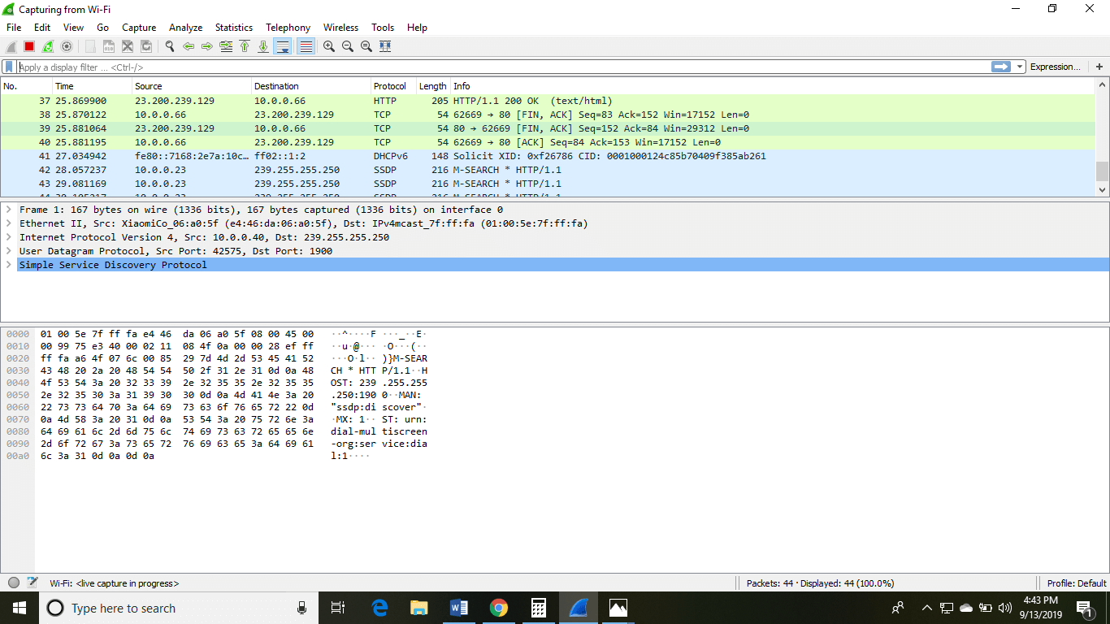

The above arrow shows the packet content written in hexadecimal or the ASCII format. And the information above the packet content, are the details of the packet header.

It will continue listening to all the data packets, and you will get much data. If you want to see a particular data, then you can click on the red button. The traffic will be stationary, and you can note the parameters like time, source, destination, the protocol being used, length, and the Info. To view in-depth detail, you can click on that particular address; a lot of the information will be displayed below that.

There will be detailed information on HTTP packets, TCP packets, etc. The red button is shown below:

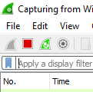

The screen/interface of the Wireshark is divided into five parts:

* First part contains a menu bar and the options displayed below it. This part is at the top of the window. File and the capture menus options are commonly used in Wireshark. The capture menu allows to start the capturing process. And the File menu is used to open and save a capture file.
* The second part is the packet listing window. It determines the packet flow or the captured packets in the traffic. It includes the packet number, time, source, destination, protocol, length, and info. We can sort the packet list by clicking on the column name.
* Next comes the packet header- detailed window. It contains detailed information about the components of the packets. The protocol info can also be expanded or minimized according to the information required.
* The bottom window called the packet contents window, which displays the content in ASCII and hexadecimal format.
* At last, is the filter field which is at the top of the display. The captured packets on the screen can be filtered based on any component according to your requirements. For example, if we want to see only the packets with the HTTP protocol, we can apply filters to that option. All the packets with HTTP as the protocol will only be displayed on the screen, shown below:

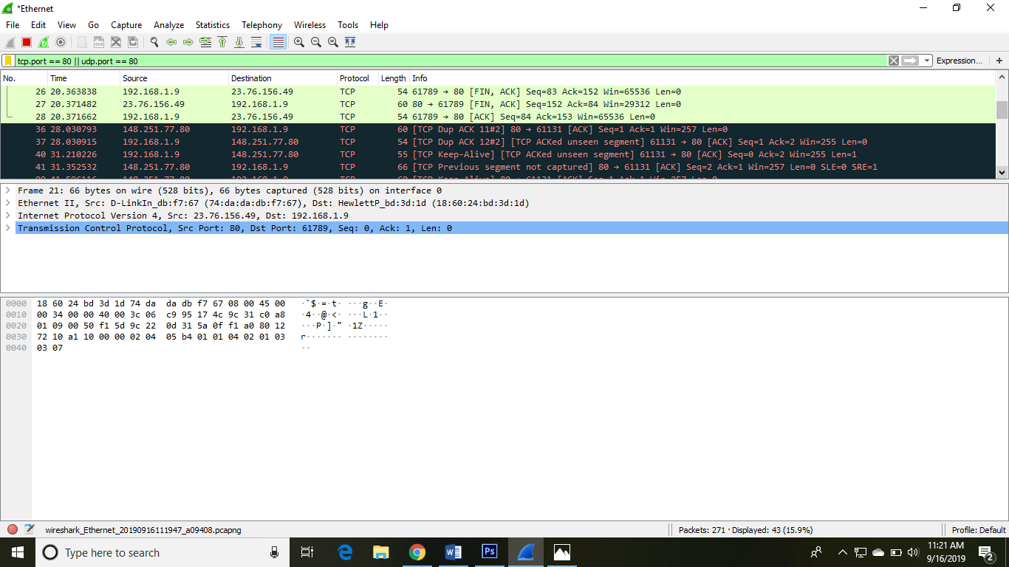

**Conclusion:** Thus we have studied the basics of Wireshark.